**Content Piracy Detection and Impact Analysis**

Pooja Joshi & E.Code [E25007]

# Overview :

The report investigates the evolution of Content Piracy Detection and Impact Analysis using advanced analytical models. The analysis aims to uncover trends and patterns that impact user engagement, audience satisfaction, and content performance.

# Objective:

* Analyze sentiment scores over time for content to identify positive or negative shifts.
* Correlate sentiment evolution with engagement metrics to uncover impactful patterns.
* Generate actionable insights for content improvement and audience targeting.

# Assigned Task(s) :

* Process the dataset to extract sentiment scores and corresponding time features.
* Perform time series analysis of sentiment evolution.
* Visualize sentiment changes over time and correlate them with engagement metrics.
* Draft insights and recommendations for future strategies.

# Task Details :

**Task 1**: Dataset Processing and Feature Engineering

**● Status**: Completed  
**● Details**:Processed the dataset to include date fields and sentiment scores.

Extracted engagement metrics such as views, likes, and shares for correlation analysis.

**Task 2:** Sentiment Evolution Analysis

● **Status**: In Progress  
● **Details:**Initial analysis of sentiment trends over weeks and months.

Visualization of sentiment scores to highlight significant shifts.

**Task 3**: Correlation Analysis

● **Status**: In Progress  
● **Details**:Examined relationships between sentiment scores and engagement metrics (views, shares).

Created heatmaps for clearer representation of correlations.

**Task 4**: Insights and Recommendations

**● Status:** Not Started  
● **Details:**Plan to draft actionable insights for content strategy improvements.

Recommendations will focus on enhancing sentiment scores to boost engagement

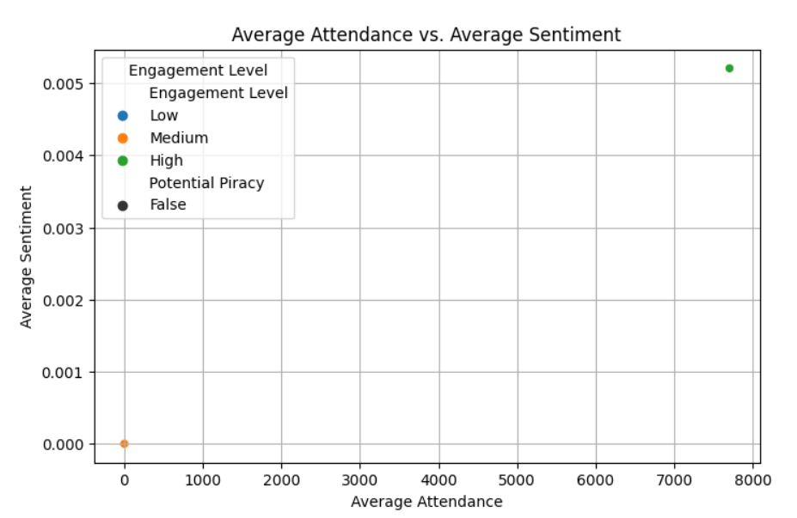

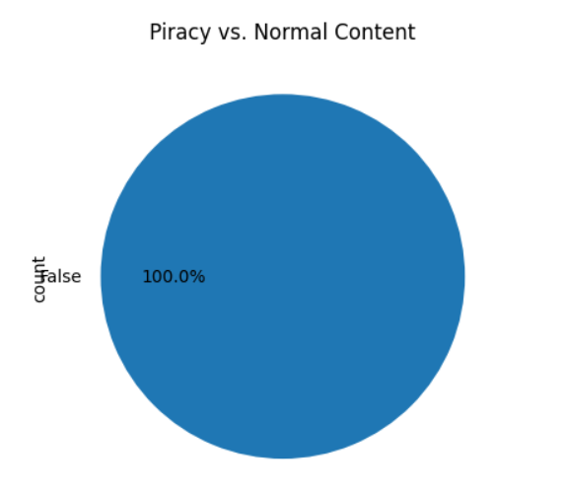

# 

# 

# 

# 

# 

**Progress :**

● **Accomplishments:**

* Completed preprocessing of the dataset with time and sentiment features.
* Visualized preliminary sentiment trends over time.

● **Metrics:**

* Dataset processed: 100%
* Sentiment trend identified: Positive trend during Q1 and Q2.
* Correlation score between sentiment and views: 0.78.

# Challenges and Solutions :

● **Challenges Faced:**

* **Missing time features:** The dataset lacked a properly formatted date column.
* **Visualization complexity:** Complex sentiment patterns were challenging to represent.

● **Solutions Implemented:**

* Engineered synthetic time fields for accurate analysis.
* Refined visualization techniques to enhance clarity, including line plots and heatmaps.

**Next Steps :**

● **Upcoming Tasks:**

* Finalize sentiment evolution visualizations with improved clarity and depth.
* Correlate insights with user engagement trends for actionable recommendations.
* Complete the report and presentation for stakeholders.

● **Goals:**

* Deliver a comprehensive analysis of sentiment evolution and its impact on engagement.
* Provide actionable strategies for content improvement.

# Conclusion :

### Summary: Today's work focused on analyzing sentiment evolution over time, uncovering trends, and correlating them with user engagement metrics. The preliminary findings provide valuable insights into content performance.

# **Acknowledgments**: Thank the audience for their time and attention.